Project Executable Files

Date | 6 July 2026
Team ID
Project Name | Smart Agricultural Production Optimization Engine
Maximum Marks | 3 Marks

Project Executable Files
This document contains all the executable and deployable components of the Smart Agricultural Production project. The project is developed using Python, Flask, HTML, CSS, JavaScript, and Machine Learning. All source files, datasets, trained model files, templates, static resources, and dependency files are organized in a structured directory, allowing evaluators to run the application with minimal setup.

Step 1: Submission Checklist
S.No | Item to Submit | Submitted (Yes / No / NA)
1 | Complete source code (all files and folders) | Yes
2 | README / Setup Guide (instructions to run the project) | Yes
3 | requirements.txt / dependency file | Yes
4 | Database schema / seed files (if applicable) | NA
5 | Environment configuration file (.env.example or similar) | NA
6 | Deployed application URL (if hosted) | No
7 | APK / Executable binary (if applicable) | NA
8 | Dockerfile / Containerization configuration | NA
9 | Test files and test results | Yes
10 | Demo video or walkthrough | Yes

Step 2: File / Folder Structure

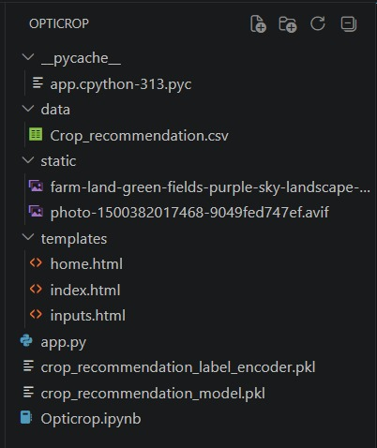

Step 3: Deployment / Access Details
Field | Details
Hosted / Deployed URL | Not Hosted (Runs Locally)
Login Credentials (Demo) | Not Required
Platform / Hosting Provider | Local Flask Development Server
Repository Link | Git-hub
Demo Video Link | Demo-link

Step 4: Run Instructions

Pre-requisites
- Python 3.10 or later
- Flask
- NumPy
- Pandas
- Scikit-learn
- Pickle (Python Standard Library)

Steps
Step 1: Download or clone the project source code.
Step 2: Open the project folder in Visual Studio Code or any Python IDE.
Step 3: Install the required dependencies using:
pip install -r requirements.txt
Step 4: Ensure that the trained machine learning model (model.pkl) and dataset are present in the project directory.
Step 5: Run the Flask application:
python app.py
Step 6: Open a web browser and navigate to:
http://127.0.0.1:5000/
Step 7: Enter the required soil and environmental parameters, then click Predict to view the recommended crop.
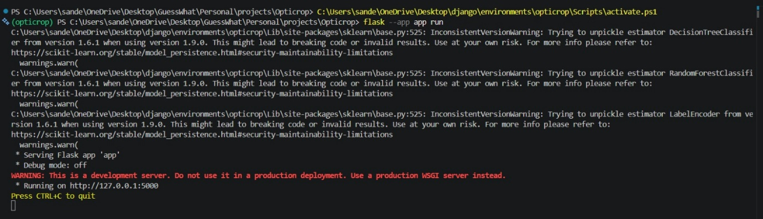
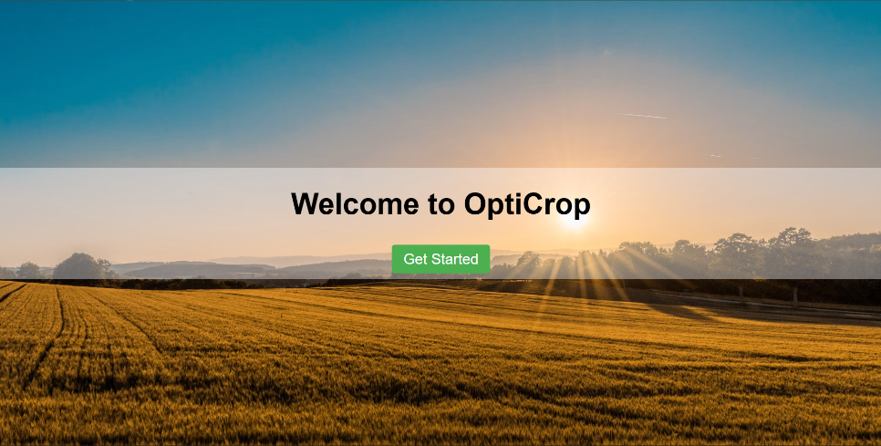
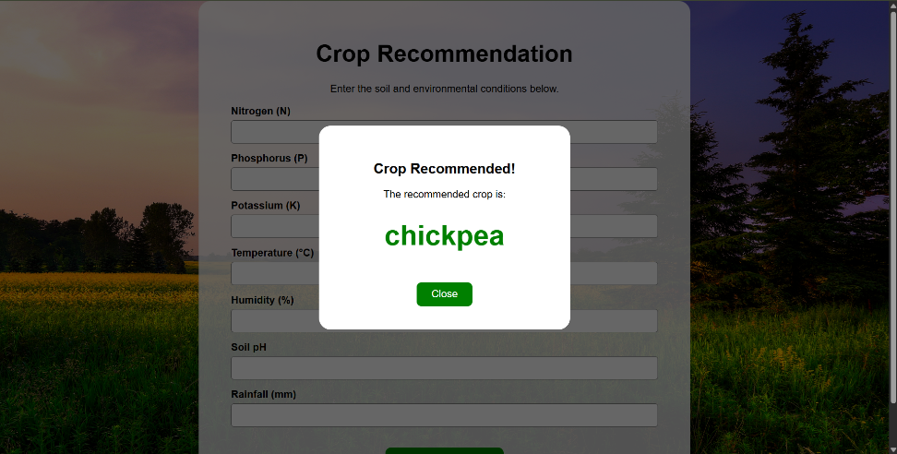

Step 5: Known Issues / Limitations
S.No | Known Issue / Limitation | Workaround / Status
1 | The application requires manually entered input values. | Future enhancement will integrate IoT sensors for automatic data collection.
2 | Real-time weather information is not integrated. | Future enhancement will include Weather API integration.
3 | The application currently runs on a local server only. | Can be deployed on cloud platforms such as Render, Railway, or PythonAnywhere in future versions.

